School Management System
Relational Database Design and Implementation using MySQL

Field | Details
Student Name | Romeo Thapa
Class | Grade 12 - Computer Science
Project Option | Option A - School Management System
Submission File | DBMS_Project_Romeo
Date | August 2026

1. Project Overview
This project implements Option A: a School Management System, a relational database that tracks students, teachers, the courses offered, and student enrollments in those courses. The database was designed following normalization principles up to Third Normal Form (3NF) and implemented in MySQL.
The system models two core relationships:
- One-to-Many: a single teacher can be assigned to teach many courses (teachers -> courses).
- Many-to-Many: a student can enroll in many courses, and a course can have many students. This is resolved with a junction table, enrollments, which also stores the enrollment date and final grade.

2. Entity-Relationship Diagram
The diagram below shows the four tables, their columns, primary keys (PK), foreign keys (FK), and the cardinality of each relationship.
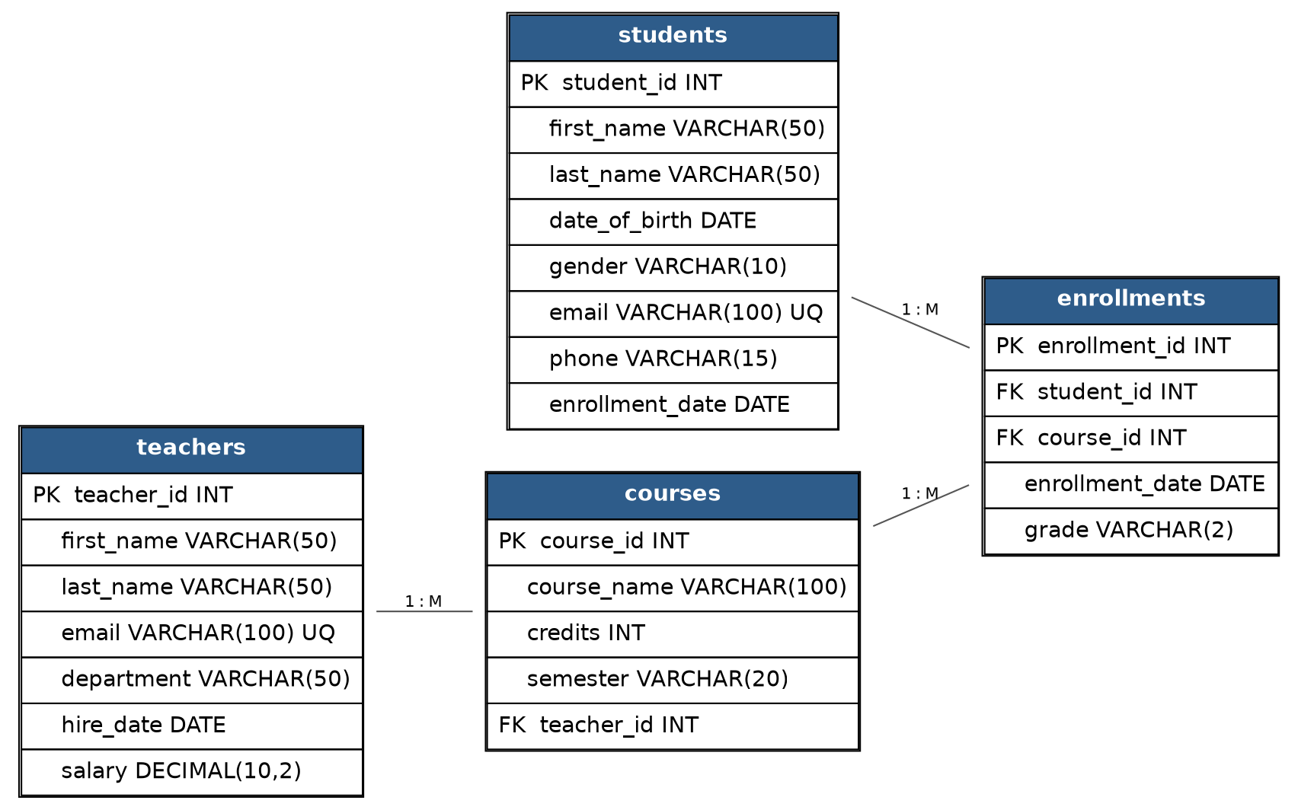
Figure 1: ER Diagram - School Management System

3. Table Design and Normalization
Each table stores a single entity, and every non-key column depends only on the primary key of its own table (2NF/3NF). Repeating groups were eliminated by moving the student-course relationship into its own junction table (enrollments) rather than storing multiple course columns inside the students table.

Table: students
Stores personal and contact details for every enrolled student.
Column | Data Type | Constraints | Purpose
student_id | INT | PK, AUTO_INCREMENT | Unique identifier for each student
first_name | VARCHAR(50) | NOT NULL | Student's first name
last_name | VARCHAR(50) | NOT NULL | Student's last name
date_of_birth | DATE | NOT NULL | Used for age/eligibility checks
gender | VARCHAR(10) | NOT NULL, CHECK | Restricted to Male / Female / Other
email | VARCHAR(100) | NOT NULL, UNIQUE | Primary contact and login identifier
phone | VARCHAR(15) | DEFAULT NULL | Optional contact number
enrollment_date | DATE | NOT NULL, DEFAULT | Date the student joined the school

Table: teachers
Stores employment details for teaching staff.
Column | Data Type | Constraints | Purpose
teacher_id | INT | PK, AUTO_INCREMENT | Unique identifier for each teacher
first_name | VARCHAR(50) | NOT NULL | Teacher's first name
last name | VARCHAR(50) | NOT NULL | Teacher's last name
email | VARCHAR(100) | NOT NULL, UNIQUE | Staff contact email
department | VARCHAR(50) | NOT NULL | Subject department
hire_date | DATE | NOT NULL | Date of joining
salary | DECIMAL(10,2) | NOT NULL, CHECK > 0 | Monthly salary

Table: courses
Stores each course offered and the teacher assigned to it (One-to-Many: one teacher can teach many courses).
Column | Data Type | Constraints | Purpose
course_id | INT | PK, AUTO_INCREMENT | Unique identifier for each course
course_name | VARCHAR(100) | NOT NULL | Name of the course
credits | INT | NOT NULL, CHECK 1-6 | Credit value of the course
semester | VARCHAR(20) | NOT NULL, DEFAULT | Semester offered
teacher_id | INT | FK -> teachers | Teacher assigned to the course

Table: enrollments

Junction table resolving the Many-to-Many relationship between students and courses, and recording the grade earned.
Column | Data Type | Constraints | Purpose
enrollment_id | INT | PK, AUTO_INCREMENT | Unique identifier for each enrollment
student_id | INT | FK -> students | Enrolled student
course_id | INT | FK -> courses | Course enrolled in
enrollment_date | DATE | NOT NULL, DEFAULT | Date of enrollment
grade | VARCHAR(2) | CHECK IN (A, B, C, D, F) | Final grade; NULL until assessed

4. Constraints Summary
- Primary Keys: every table has a single-column surrogate primary key (student_id, teacher_id, course_id, enrollment_id) that auto-increments.
- Foreign Keys: courses.teacher_id references teachers.teacher_id; enrollments.student_id references students.student_id; enrollments.course_id references courses.course_id.
- Referential actions: deleting a teacher sets courses.teacher_id to NULL (ON DELETE SET NULL) so course history is preserved; deleting a student or course cascades to remove the related enrollment rows (ON DELETE CASCADE).
- Uniqueness: students.email and teachers.email are UNIQUE; a UNIQUE constraint on (student_id, course_id) in enrollments prevents duplicate enrollments in the same course.
- Domain checks: CHECK constraints restrict gender, credits, salary, and grade to valid values.

5. Data Seeding
The script inserts 8 teachers, 10 students, 8 courses, and 14 enrollment records with realistic sample values, satisfying the 5-10 records per table requirement and providing enough data for meaningful joins and aggregates.

6. Queries and Analytics
All queries below were executed against the populated database. Each screenshot shows the exact SQL statement and the resulting output.

Query 1 - Basic Retrieval (WHERE, ORDER BY, LIMIT)
Retrieves the 5 most recently enrolled students who were born after 31 Dec 2007, sorted by enrollment date (most recent first).
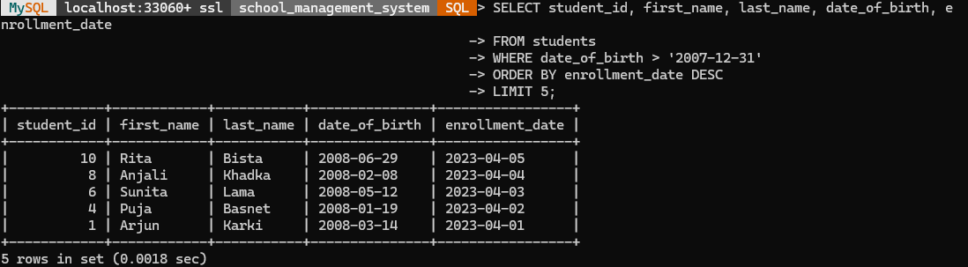

Query 2 - Aggregate Function (GROUP BY / HAVING)
Counts the number of students enrolled in each course and returns only the courses with 2 or more students, demonstrating COUNT(), GROUP BY, and HAVING.
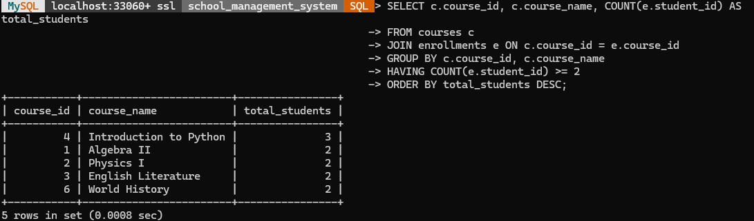

Query 3 - Subquery
Uses a nested query in the WHERE clause to find teachers whose salary is above the average salary of all teachers.
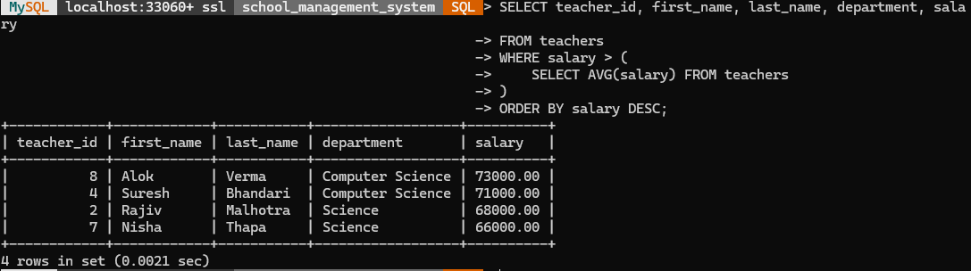

Query 4a - INNER JOIN
Joins courses with teachers to list every course alongside the name and department of the teacher who instructs it.
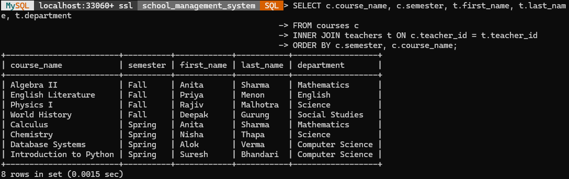

Query 4b - LEFT JOIN
Joins students with enrollments and courses so that every student appears in the result, including those currently enrolled in no course (e.g. student_id 5, after the DELETE demonstrated below).
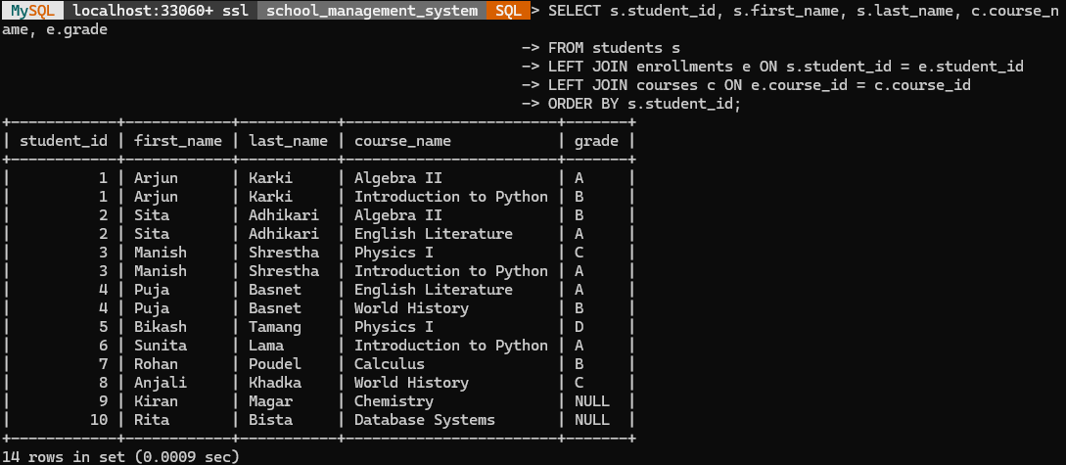

Query 5 - Data Modification (UPDATE and DELETE)
An UPDATE statement corrects a student's email address after they reported it had changed, and a DELETE statement removes a single enrollment record for a student who dropped a course. Both statements use a precise WHERE clause on primary/foreign key columns to avoid affecting unintended rows:
UPDATE students
SET email = 'arjun.karki.new@student.edu'
WHERE student_id = 1;
DELETE FROM enrollments
WHERE student_id = 5 AND course_id = 2;
The effect of the DELETE is visible in the Query 4b (LEFT JOIN) screenshot above: student_id 5 (Bikash Tamang) now shows NULL for course_name and grade, confirming that Bikash's only enrollment (in course_id 2) was successfully removed while all other students' records remained unaffected.

7. Conclusion
The School Management System database satisfies all three project phases: a normalized four-table schema with enforced primary/foreign keys and constraints; a populated MySQL database with realistic sample data; and a full set of analytical queries covering filtering, aggregation, subqueries, joins, and data modification. The complete, runnable script is provided in database_setup.sql.

